26 March 2019
Forgotten Games
How childish you are! This is not the type of game a grown up plays. Just grow up dude.Huhhhhhh.
We all must have listened such lines at least once in our life. As soon as our schooling is done we join the rat race of seeking career oriented courses or degrees. We kill the child within us, the child who wants to guffaw. We stopped playing those Indian traditional games which used to give us pleasure.
Let's reminisce about those wonderful games and forget for a while that we have grown up.
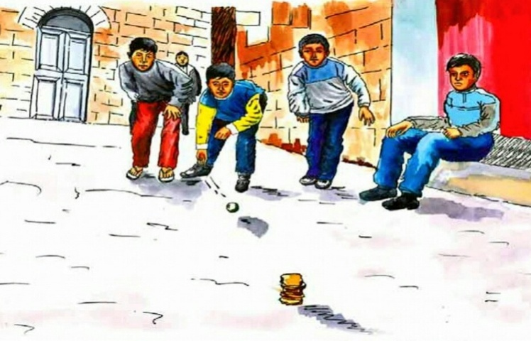
➡The most wonderful game I had ever played is PithuGaram or Seven Stones. It is played between two teams. The game requires a rag ball and set of seven stones which can be stacked up to form a small tower. The aim of the game is to be able to break the tower and then rebuild it before getting hit by one of the opponent.
➡ Another elbow greasing game is Pakadam-Pakdai/ ChorSipaahi or Tag. There are two teams in the game – one team of thieves (chor)and the other team of sipahi (police). The sipahi try and catch the chor, after which the turn changes (that is, the chor become the sipahi and vice versa)
➡ One of the the popular games is GilliDanda. It is a game very similar to cricket. The game is played with a small piece of wood reduced on both sides known as gilli and a large piece of wood that is used to hit the gilli known as danda. The aim of the game is to hit the gilli as far as possible. But be alert gilli might hit your eyes. People stopped playing it in fear of being hit by gilli rather than finding some way out to avoid mishaps.
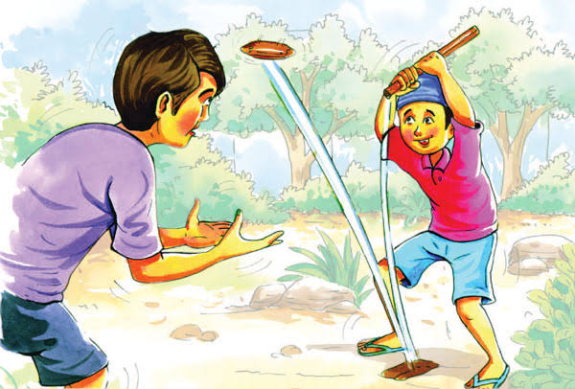
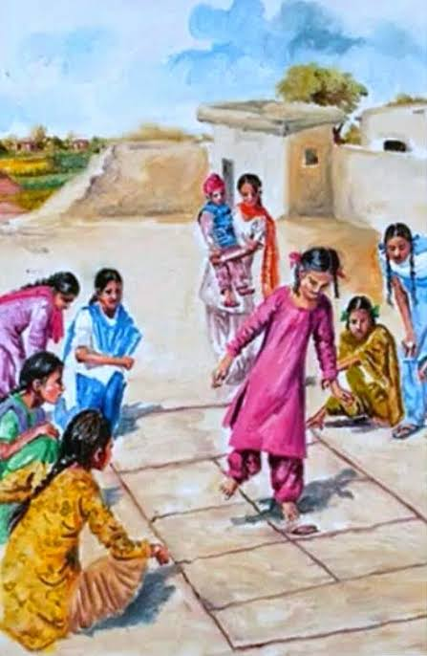
➡ Winters arrived so lets play Stapoo. Stapoo or Tappu a popular playground game in which players throw a small object into numbered spaces of a pattern of rectangles marked on the ground and then hop or jump through the spaces on one or two legs to retrieve the object. It was most played game during winters.

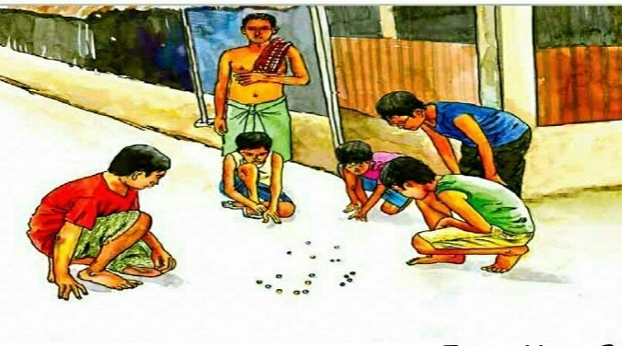
➡ I still remember when my brother gave me 160 marbles which he won playing during dusty, gusty, hot and dry summer day. Marbles (Kancha) is still a popular game among kids in rural areas. The game is played with round glass marbles and the motive is to collect as many marbles as possible by shooting and striking other marbles with the ones you have.
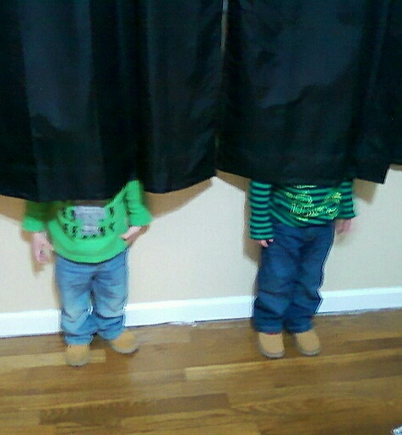
➡ I can't forget the day when I hid myself in a storeroom and waited half an hour for someone to come and say AAYISH PAYISH. 😭 Everyone went back their houses without informing me. ChhupamChhupai or Hide and Seek is a popular game in which players hide themselves in a marked area, to be found by one or more seekers/denners. The denner closes his eyes and counts till a certain number, after which he tries to find the hidden players. I was always made fool in this game
➡ Four corners is a game often played by primary school children. Four corners are designated, and a player is chosen as being “it”. The remaining players have to swap corners without being caught by “it”. If a player is caught by “it” or is without a free corner to stand in, he becomes “it”.
It does not end here. There are several more games which are irreplaceable as Lattu, Langdi, Chokhar, Ooch-Nich, Vish-Amrit, Kho-Kho, KolhadaJamai, Antakshari, Saanp-Seedhi, Poshampa and many more.
These games must remind you early days when there was no question of choice. 'Just play and enjoy' such was the attitude we carried. My purpose to remind you these games is not just to enlighten you but I hope we all let the child inside us live its life at the fullest. Let's not forget our culture and save it by maintaining its originality.
Mr. Karam
(English Facilitator,PGSP)

